Министерство науки и высшего образования РФ

Федеральное государственное автономное образовательное учреждение высшего образования «Омский государственный технический университет»

Кафедра «Автоматизированные системы обработки информации и управления»

ОТЧЁТ ПО ДОМАШНЕМУ ЗАДАНИЮ

по дисциплине «Машинное обучение»

студента Мусайбекова Адиля Туяновича группы ПИН-241

Пояснительная записка

Шифр работы От-2068998-43-ПИН-05-24 ПЗ

Направление 09.03.04

Доцент, к.т.н. О.Б. Малков

Студент Мусайбеков А.Т

Омск 2026

СОДЕРЖАНИЕ

Задание 3
1. Загрузка данных и первичный просмотр 5
2. Вывод 9 первых и 6 последних строк 5
3.Общая информация о датасете 6
4.Статистика числовых признаков 7
5.Анализ категориального признака team 8
6.Группировка и агрегация (groupby) 9
7.Группировка по количеству игроков 11
8.Сводные таблицы (pivot_table) 12
9.Сохранение датафрейма 15
СПИСОК ИСПОЛЬЗОВАННЫХ ИСТОЧНИКОВ 16
ПРИЛОЖЕНИЕ А 17

Задание

1. Загрузите датасет football.csv и поместите его в датафрейм.

2. Выведите 9 первых и 6 последних строк.

3. Получите общую информацию о датасете с помощью метода info().

4. Выведите с помощью метода describe() основные статистические показатели для всех числовых признаков.

5. Для категориального признака team определите количество уникальных категорий и частоту встречаемости каждой из них.

6. С помощью groupby() и agg() определите:

• какие команды были самыми результативными (сумма голов) и самыми точными (средний % точности ударов);

• какие команды совершили больше всего фолов, получили больше всего желтых и красных карточек;

• насколько равномерно использовался состав. Посчитайте среднее и стандартное отклонение по количеству использованных игроков для всех команд;

• ТОП-5 команд по разным показателям: общему количеству ударов в створ, лучшему соотношению сэйвов к ударам, худшей дисциплине (сумма желтых и красных карточек).

7. Разбейте команды на группы по количеству использованных игроков (например, 11-15, 16-20, 21-23). Для каждой группы посчитайте среднее количество голов.

8. С помощью pivot_table() постройте сводные таблицы, показывающие:

• какие команды были эффективнее в завершении, где строка – команда, а столбцы – средние значения: goals-to-shots, shooting accuracy, hit woodwork;

• указание на атакующий футбол с длинными передачами, группировка команд по их стилю: много ли они выигрывают фолов и при этом часто попадают в офсайд;

• эффективность реализации пенальти, где отображаются: команды, количество назначенных пенальти (penalty goals + penalties not scored), процент реализации (penalty goals / общее кол-во * 100%).

9. Сохраните столбцы Team, Yellow Cards и Red Cards как датафрейм с именем discipline и отсортируйте его по Red Cards и Yellow Cards.

10. Выведите полученные датафреймы на диск в виде CSV-файлов.

Загрузка данных и первичный просмотр

Импортированы библиотеки. Датасет загружен из файла football.csv с помощью функции pd.read_csv(). Результат помещён в датафрейм df (рис. 1).

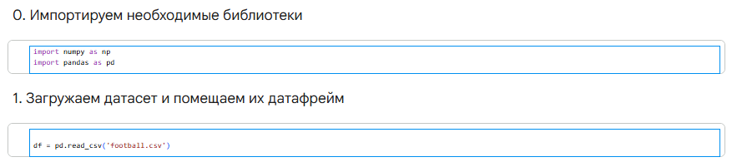

Рисунок 1 – Код импорта библиотек и загрузки данных

Вывод 9 первых и 6 последних строк

Выведены первые 9 строк методом df.head() и последние 6 строк методом df.tail() (рис. 2).

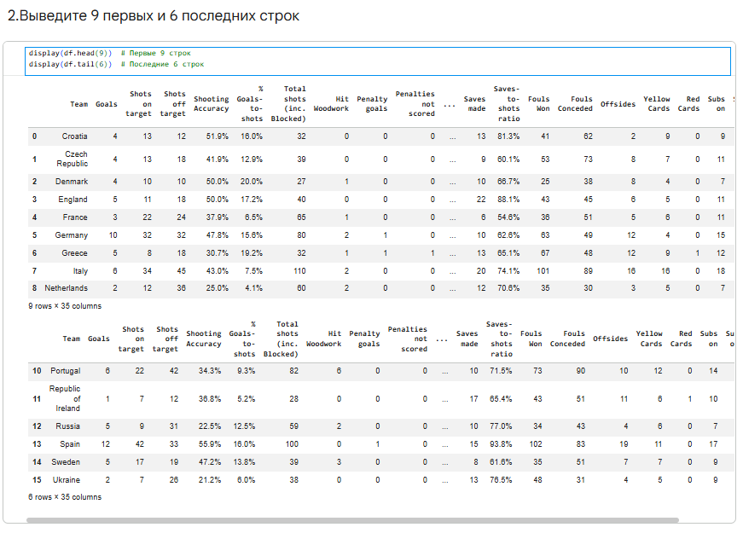

Рисунок 2 – Результат df.head() и df.tail()

3.Общая информация о датасете

Метод info() показал, что датасет содержит 16 строк и 35 столбцов. Признаки Shooting Accuracy, % Goals-to-shots, Passing Accuracy, Saves-to-shots ratio имеют тип object (содержат символ %). Признак Clearances off line содержит 1 пропуск (рис. 3).

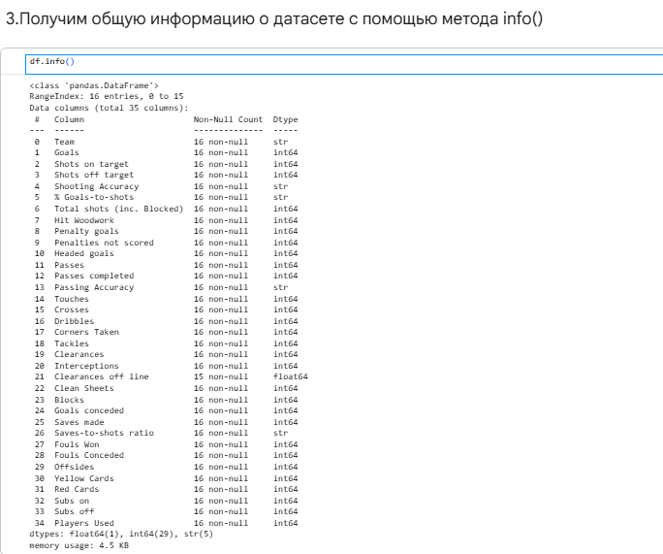

Рисунок 3 – Вывод df.info()

4.Статистика числовых признаков

Метод describe() вывел основные статистики для числовых признаков: Goals, Shots on target, Shots off target, Total shots, Passes, Tackles, Yellow Cards, Red Cards и другие (рис. 4).

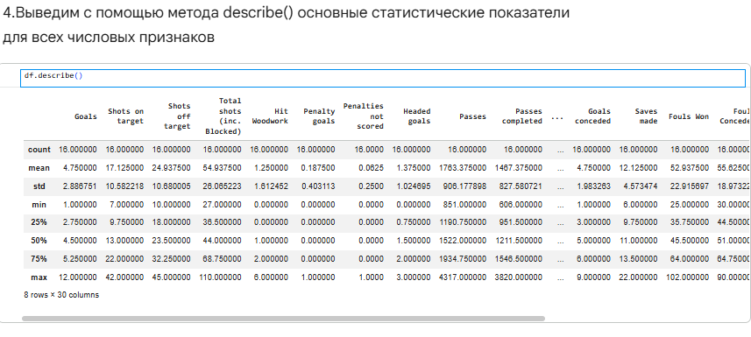

Рисунок 4 – Результат df.describe()

5.Анализ категориального признака team

Для столбца team определено количество уникальных категорий — 16 (все команды представлены по одному разу) (рис. 5).

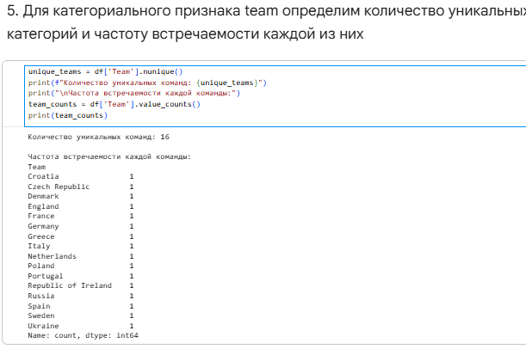

Рисунок 5 – Уникальные значения и частоты team

6.Группировка и агрегация (groupby)
Самые результативные и самые точные команды. Группировка по team показала: Испания — лучшая по голам (12) и точности (55.9%); Германия — 10 голов и 47.8% точности; Португалия — 6 голов и 34.3% точности.
Дисциплина команд. Италия получила больше всех жёлтых карточек (16), Португалия совершила больше всего фолов (90). Греция и Польша получили по 1 красной карточке.
Равномерность использования состава. Среднее количество использованных игроков — 17.25, стандартное отклонение — 1.53. Это говорит о том, что все команды использовали состав достаточно равномерно.

.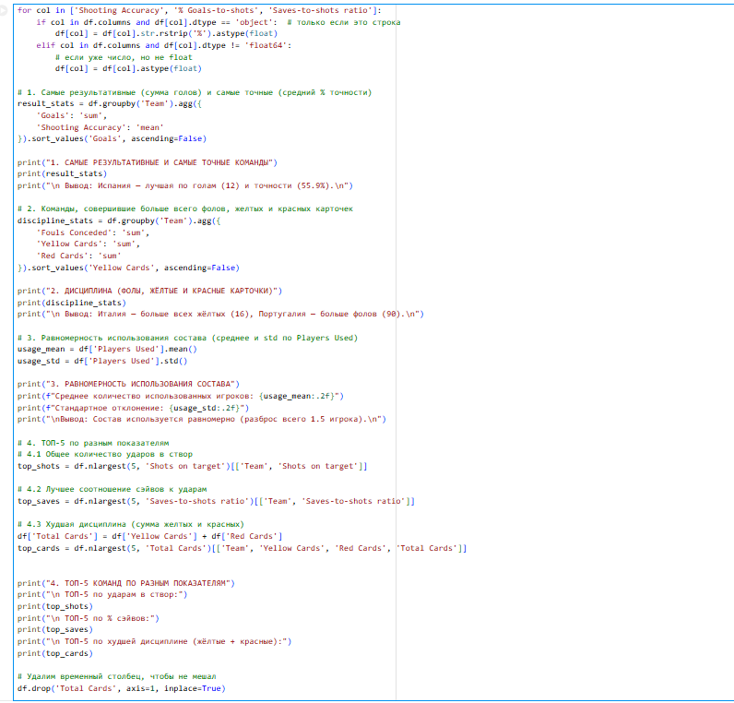

Рисунок 6 – Код для результатов и точности команды

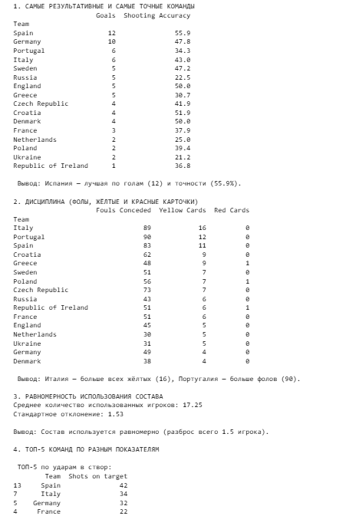

Рисунок 7 – Вывод результатов и точности команды

7.Группировка по количеству игроков
Команды разбиты на группы по количеству использованных игроков: 11-15 и 16-20 (группа 21-23 отсутствует). Среднее количество голов в группе 11-15 — 3.0, в группе 16-20 — 5.0. Команды, использовавшие больше игроков, забивали в среднем больше голов (рис. 10).

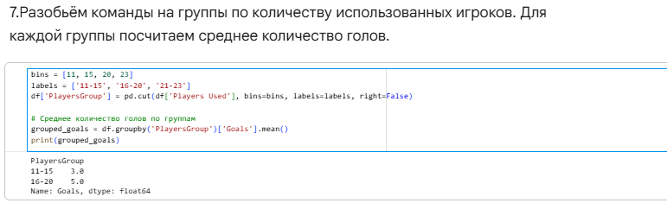

Рисунок 8 – среднее количество голов по группам игроков

8.Сводные таблицы (pivot_table)
Эффективность завершения атак. Построена сводная таблица: строки — команды, столбцы — средние значения % Goals-to-shots, Shooting Accuracy, Hit Woodwork. Дания показала лучшую эффективность (20% голов от ударов), Испания — лучшую точность (55.9%), Португалия чаще других попадала в штангу (6 раз).
Атакующий стиль. Построена таблица: строки — команды, столбцы — Fouls Won и Offsides. Италия выиграла больше всех фолов (101), Испания чаще всех попадала в офсайд (19 раз). Это указывает на атакующий стиль с высоким прессингом и длинными передачами.
Эффективность реализации пенальти. Построена таблица: команды, количество назначенных пенальти и процент реализации. Германия — единственная команда, реализовавшая 100% пенальти (1 из 1). Греция и Испания получили по 2 пенальти, но реализовали только 50%.
Все три сводные таблицы построены с использованием метода pivot_table() (рис. 11-13).

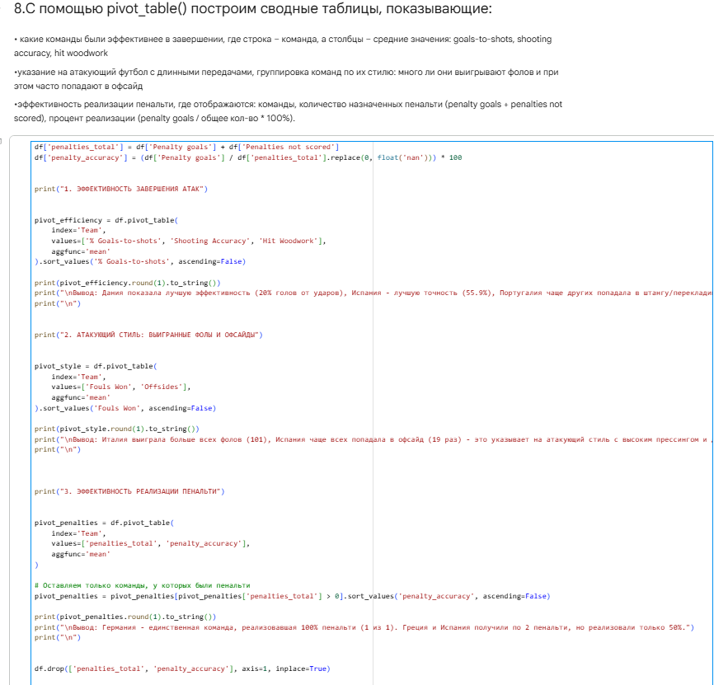
Рисунок 9– Код для сводных таблиц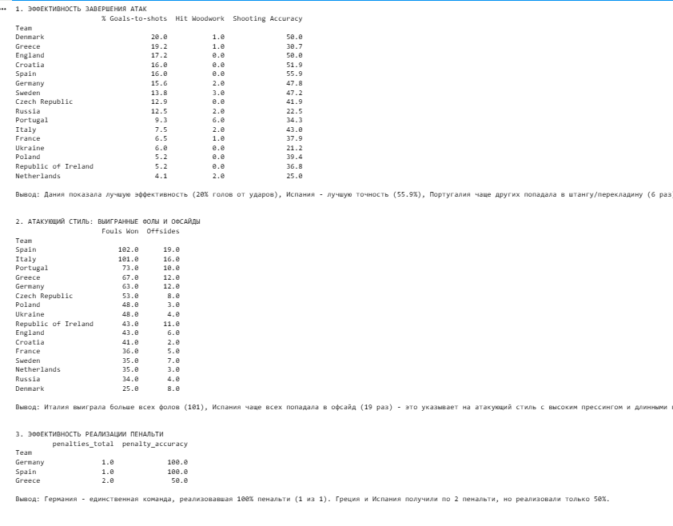
Рисунок 10– Вывод сводных таблиц

9.Сохранение датафрейма
Создан датафрейм discipline с колонками Team, Yellow Cards, Red Cards, отсортированный по убыванию Red Cards и Yellow Cards. Датафрейм сохранён в файл discipline.csv (рис. 14).
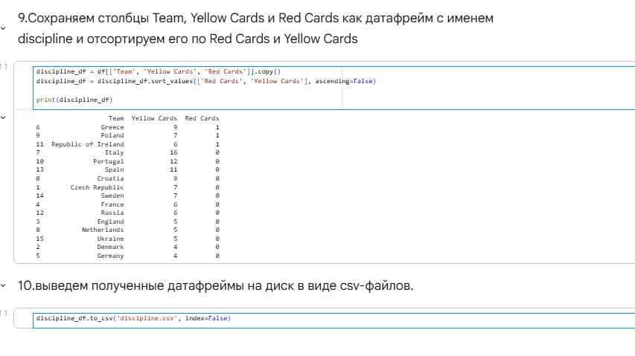
Рисунок 11 – Код сохранения.

СПИСОК ИСПОЛЬЗОВАННЫХ ИСТОЧНИКОВ

User Guide [Электронный ресурс] – Режим доступа: https://pandas.pydata.org/docs/user_guide/index.html.

Jupyter [Электронный ресурс] – Режим доступа: https://jupyter.org/.

Руководство библиотеке Pandas [Электронный ресурс] – Режим доступа: https://metanit.com/python/pandas/.

NumPy [Электронный ресурс] – Режим доступа: https://numpy.org/.

ПРИЛОЖЕНИЕ А

(обязательное)
Листинг кода Jupyter Notebook (LR1.ipynb)
{
"cells": [
{
"cell_type": "markdown",
"id": "ba8VG1YsWISa",
"metadata": {},
"source": [
"# Лабораторная работа № 1\n",
"# Работа с библиотекой pandas\n",
"**Цель работы:** изучить программные средства, используемые для визуализации наборов данных\n",
"\n",
"Выполним анализ набора данных «Характеристики футбольных команд». Набор представляет собой данные о статистике команд в футбольном турнире (голы, удары, пасы, фолы и прочие). Набор данных подходит для обучения моделей регрессии, моделей классификации. Набор данных включает следующие атрибуты:\n",
"- **Team** – название команды;\n",
"- **Goals** – забитые голы;\n",
"- **Shots on target** – удары в створ ворот;\n",
"- **Shots off target** – удары мимо ворот;\n",
"- **Shooting Accuracy** – точность ударов;\n",
"- **% Goals-to-shots** – процент голов от ударов;\n",
"- **Total shots (inc. Blocked)** – всего ударов (включая заблокированные);\n",
"- **Hit Woodwork** – попадания в штангу/перекладину;\n",
"- **Penalty goals** – голы с пенальти;\n",
"- **Penalties not scored** – нереализованные пенальти;\n",
"- **Headed goals** – голы головой;\n",
"- **Passes** – пасы;\n",
"- **Passes completed** – точные пасы;\n",
"- **Passing Accuracy** – точность пасов;\n",
"- **Touches** – касания мяча;\n",
"- **Crosses** – навесы;\n",
"- **Dribbles** – обводки;\n",
"- **Corners Taken** – угловые;\n",
"- **Tackles** – отборы;\n",
"- **Clearances** – выносы мяча;\n",
"- **Interceptions** – перехваты;\n",
"- **Clearances off line** – выносы с линии ворот;\n",
"- **Clean Sheets** – \"сухие\" матчи;\n",
"- **Blocks** – блокировки ударов;\n",
"- **Goals conceded** – пропущенные голы;\n",
"- **Saves made** – сейвы;\n",
"- **Saves-to-shots ratio** – процент сейвов;\n",
"- **Fouls Won** – заработанные фолы;\n",
"- **Fouls Conceded** – совершенные фолы;\n",
"- **Offsides** – офсайды;\n",
"- **Yellow Cards** – желтые карточки;\n",
"- **Red Cards** – красные карточки;\n",
"- **Subs on** – замены на выход;\n",
"- **Subs off** – замены на вход;\n",
"- **Players Used** – использованные игроки."
]
},
{
"cell_type": "markdown",
"id": "HQGC5nkkW7W-",
"metadata": {},
"source": [
"#0. Импортируем необходимые библиотеки"
]
},
{
"cell_type": "code",
"execution_count": 1,
"id": "qJ3mgxChW-Rj",
"metadata": {},
"outputs": [],
"source": [
"import numpy as np\n",
"import pandas as pd"
]
},
{
"cell_type": "markdown",
"id": "zkYH5PqMXEMg",
"metadata": {},
"source": [
"#1. Загружаем датасет и помещаем их датафрейм"
]
},
{
"cell_type": "code",
"execution_count": 2,
"id": "3078c7f3",
"metadata": {},
"outputs": [],
"source": [
"df = pd.read_csv('football.csv')"
]
},
{
"cell_type": "markdown",
"id": "AdEU20jeWKFG",
"metadata": {},
"source": [
"#2.Выведите 9 первых и 6 последних строк"
]
},
{
"cell_type": "code",
"execution_count": 3,
"id": "fbd7c71e",
"metadata": {},
"outputs": [
{
"data": {
"text/html": [
"<div>\n",
"<style scoped>\n",
" .dataframe tbody tr th:only-of-type {\n",
" vertical-align: middle;\n",
" }\n",
"\n",
" .dataframe tbody tr th {\n",
" vertical-align: top;\n",
" }\n",
"\n",
" .dataframe thead th {\n",
" text-align: right;\n",
" }\n",
"</style>\n",
"<table border=\"1\" class=\"dataframe\">\n",
" <thead>\n",
" <tr style=\"text-align: right;\">\n",
" <th></th>\n",
" <th>Team</th>\n",
" <th>Goals</th>\n",
" <th>Shots on target</th>\n",
" <th>Shots off target</th>\n",
" <th>Shooting Accuracy</th>\n",
" <th>% Goals-to-shots</th>\n",
" <th>Total shots (inc. Blocked)</th>\n",
" <th>Hit Woodwork</th>\n",
" <th>Penalty goals</th>\n",
" <th>Penalties not scored</th>\n",
" <th>...</th>\n",
" <th>Saves made</th>\n",
" <th>Saves-to-shots ratio</th>\n",
" <th>Fouls Won</th>\n",
" <th>Fouls Conceded</th>\n",
" <th>Offsides</th>\n",
" <th>Yellow Cards</th>\n",
" <th>Red Cards</th>\n",
" <th>Subs on</th>\n",
" <th>Subs off</th>\n",
" <th>Players Used</th>\n",
" </tr>\n",
" </thead>\n",
" <tbody>\n",
" <tr>\n",
" <th>0</th>\n",
" <td>Croatia</td>\n",
" <td>4</td>\n",
" <td>13</td>\n",
" <td>12</td>\n",
" <td>51.9%</td>\n",
" <td>16.0%</td>\n",
" <td>32</td>\n",
" <td>0</td>\n",
" <td>0</td>\n",
" <td>0</td>\n",
" <td>...</td>\n",
" <td>13</td>\n",
" <td>81.3%</td>\n",
" <td>41</td>\n",
" <td>62</td>\n",
" <td>2</td>\n",
" <td>9</td>\n",
" <td>0</td>\n",
" <td>9</td>\n",
" <td>9</td>\n",
" <td>16</td>\n",
" </tr>\n",
" <tr>\n",
" <th>1</th>\n",
" <td>Czech Republic</td>\n",
" <td>4</td>\n",
" <td>13</td>\n",
" <td>18</td>\n",
" <td>41.9%</td>\n",
" <td>12.9%</td>\n",
" <td>39</td>\n",
" <td>0</td>\n",
" <td>0</td>\n",
" <td>0</td>\n",
" <td>...</td>\n",
" <td>9</td>\n",
" <td>60.1%</td>\n",
" <td>53</td>\n",
" <td>73</td>\n",
" <td>8</td>\n",
" <td>7</td>\n",
" <td>0</td>\n",
" <td>11</td>\n",
" <td>11</td>\n",
" <td>19</td>\n",
" </tr>\n",
" <tr>\n",
" <th>2</th>\n",
" <td>Denmark</td>\n",
" <td>4</td>\n",
" <td>10</td>\n",
" <td>10</td>\n",
" <td>50.0%</td>\n",
" <td>20.0%</td>\n",
" <td>27</td>\n",
" <td>1</td>\n",
" <td>0</td>\n",
" <td>0</td>\n",
" <td>...</td>\n",
" <td>10</td>\n",
" <td>66.7%</td>\n",
" <td>25</td>\n",
" <td>38</td>\n",
" <td>8</td>\n",
" <td>4</td>\n",
" <td>0</td>\n",
" <td>7</td>\n",
" <td>7</td>\n",
" <td>15</td>\n",
" </tr>\n",
" <tr>\n",
" <th>3</th>\n",
" <td>England</td>\n",
" <td>5</td>\n",
" <td>11</td>\n",
" <td>18</td>\n",
" <td>50.0%</td>\n",
" <td>17.2%</td>\n",
" <td>40</td>\n",
" <td>0</td>\n",
" <td>0</td>\n",
" <td>0</td>\n",
" <td>...</td>\n",
" <td>22</td>\n",
" <td>88.1%</td>\n",
" <td>43</td>\n",
" <td>45</td>\n",
" <td>6</td>\n",
" <td>5</td>\n",
" <td>0</td>\n",
" <td>11</td>\n",
" <td>11</td>\n",
" <td>16</td>\n",
" </tr>\n",
" <tr>\n",
" <th>4</th>\n",
" <td>France</td>\n",
" <td>3</td>\n",
" <td>22</td>\n",
" <td>24</td>\n",
" <td>37.9%</td>\n",
" <td>6.5%</td>\n",
" <td>65</td>\n",
" <td>1</td>\n",
" <td>0</td>\n",
" <td>0</td>\n",
" <td>...</td>\n",
" <td>6</td>\n",
" <td>54.6%</td>\n",
" <td>36</td>\n",
" <td>51</td>\n",
" <td>5</td>\n",
" <td>6</td>\n",
" <td>0</td>\n",
" <td>11</td>\n",
" <td>11</td>\n",
" <td>19</td>\n",
" </tr>\n",
" <tr>\n",
" <th>5</th>\n",
" <td>Germany</td>\n",
" <td>10</td>\n",
" <td>32</td>\n",
" <td>32</td>\n",
" <td>47.8%</td>\n",
" <td>15.6%</td>\n",
" <td>80</td>\n",
" <td>2</td>\n",
" <td>1</td>\n",
" <td>0</td>\n",
" <td>...</td>\n",
" <td>10</td>\n",
" <td>62.6%</td>\n",
" <td>63</td>\n",
" <td>49</td>\n",
" <td>12</td>\n",
" <td>4</td>\n",
" <td>0</td>\n",
" <td>15</td>\n",
" <td>15</td>\n",
" <td>17</td>\n",
" </tr>\n",
" <tr>\n",
" <th>6</th>\n",
" <td>Greece</td>\n",
" <td>5</td>\n",
" <td>8</td>\n",
" <td>18</td>\n",
" <td>30.7%</td>\n",
" <td>19.2%</td>\n",
" <td>32</td>\n",
" <td>1</td>\n",
" <td>1</td>\n",
" <td>1</td>\n",
" <td>...</td>\n",
" <td>13</td>\n",
" <td>65.1%</td>\n",
" <td>67</td>\n",
" <td>48</td>\n",
" <td>12</td>\n",
" <td>9</td>\n",
" <td>1</td>\n",
" <td>12</td>\n",
" <td>12</td>\n",
" <td>20</td>\n",
" </tr>\n",
" <tr>\n",
" <th>7</th>\n",
" <td>Italy</td>\n",
" <td>6</td>\n",
" <td>34</td>\n",
" <td>45</td>\n",
" <td>43.0%</td>\n",
" <td>7.5%</td>\n",
" <td>110</td>\n",
" <td>2</td>\n",
" <td>0</td>\n",
" <td>0</td>\n",
" <td>...</td>\n",
" <td>20</td>\n",
" <td>74.1%</td>\n",
" <td>101</td>\n",
" <td>89</td>\n",
" <td>16</td>\n",
" <td>16</td>\n",
" <td>0</td>\n",
" <td>18</td>\n",
" <td>18</td>\n",
" <td>19</td>\n",
" </tr>\n",
" <tr>\n",
" <th>8</th>\n",
" <td>Netherlands</td>\n",
" <td>2</td>\n",
" <td>12</td>\n",
" <td>36</td>\n",
" <td>25.0%</td>\n",
" <td>4.1%</td>\n",
" <td>60</td>\n",
" <td>2</td>\n",
" <td>0</td>\n",
" <td>0</td>\n",
" <td>...</td>\n",
" <td>12</td>\n",
" <td>70.6%</td>\n",
" <td>35</td>\n",
" <td>30</td>\n",
" <td>3</td>\n",
" <td>5</td>\n",
" <td>0</td>\n",
" <td>7</td>\n",
" <td>7</td>\n",
" <td>15</td>\n",
" </tr>\n",
" </tbody>\n",
"</table>\n",
"<p>9 rows × 35 columns</p>\n",
"</div>"
],
"text/plain": [
" Team Goals Shots on target Shots off target Shooting Accuracy \\\n",
"0 Croatia 4 13 12 51.9% \n",
"1 Czech Republic 4 13 18 41.9% \n",
"2 Denmark 4 10 10 50.0% \n",
"3 England 5 11 18 50.0% \n",
"4 France 3 22 24 37.9% \n",
"5 Germany 10 32 32 47.8% \n",
"6 Greece 5 8 18 30.7% \n",
"7 Italy 6 34 45 43.0% \n",
"8 Netherlands 2 12 36 25.0% \n",
"\n",
" % Goals-to-shots Total shots (inc. Blocked) Hit Woodwork Penalty goals \\\n",
"0 16.0% 32 0 0 \n",
"1 12.9% 39 0 0 \n",
"2 20.0% 27 1 0 \n",
"3 17.2% 40 0 0 \n",
"4 6.5% 65 1 0 \n",
"5 15.6% 80 2 1 \n",
"6 19.2% 32 1 1 \n",
"7 7.5% 110 2 0 \n",
"8 4.1% 60 2 0 \n",
"\n",
" Penalties not scored ... Saves made Saves-to-shots ratio Fouls Won \\\n",
"0 0 ... 13 81.3% 41 \n",
"1 0 ... 9 60.1% 53 \n",
"2 0 ... 10 66.7% 25 \n",
"3 0 ... 22 88.1% 43 \n",
"4 0 ... 6 54.6% 36 \n",
"5 0 ... 10 62.6% 63 \n",
"6 1 ... 13 65.1% 67 \n",
"7 0 ... 20 74.1% 101 \n",
"8 0 ... 12 70.6% 35 \n",
"\n",
" Fouls Conceded Offsides Yellow Cards Red Cards Subs on Subs off \\\n",
"0 62 2 9 0 9 9 \n",
"1 73 8 7 0 11 11 \n",
"2 38 8 4 0 7 7 \n",
"3 45 6 5 0 11 11 \n",
"4 51 5 6 0 11 11 \n",
"5 49 12 4 0 15 15 \n",
"6 48 12 9 1 12 12 \n",
"7 89 16 16 0 18 18 \n",
"8 30 3 5 0 7 7 \n",
"\n",
" Players Used \n",
"0 16 \n",
"1 19 \n",
"2 15 \n",
"3 16 \n",
"4 19 \n",
"5 17 \n",
"6 20 \n",
"7 19 \n",
"8 15 \n",
"\n",
"[9 rows x 35 columns]"
]
},
"metadata": {},
"output_type": "display_data"
},
{
"data": {
"text/html": [
"<div>\n",
"<style scoped>\n",
" .dataframe tbody tr th:only-of-type {\n",
" vertical-align: middle;\n",
" }\n",
"\n",
" .dataframe tbody tr th {\n",
" vertical-align: top;\n",
" }\n",
"\n",
" .dataframe thead th {\n",
" text-align: right;\n",
" }\n",
"</style>\n",
"<table border=\"1\" class=\"dataframe\">\n",
" <thead>\n",
" <tr style=\"text-align: right;\">\n",
" <th></th>\n",
" <th>Team</th>\n",
" <th>Goals</th>\n",
" <th>Shots on target</th>\n",
" <th>Shots off target</th>\n",
" <th>Shooting Accuracy</th>\n",
" <th>% Goals-to-shots</th>\n",
" <th>Total shots (inc. Blocked)</th>\n",
" <th>Hit Woodwork</th>\n",
" <th>Penalty goals</th>\n",
" <th>Penalties not scored</th>\n",
" <th>...</th>\n",
" <th>Saves made</th>\n",
" <th>Saves-to-shots ratio</th>\n",
" <th>Fouls Won</th>\n",
" <th>Fouls Conceded</th>\n",
" <th>Offsides</th>\n",
" <th>Yellow Cards</th>\n",
" <th>Red Cards</th>\n",
" <th>Subs on</th>\n",
" <th>Subs off</th>\n",
" <th>Players Used</th>\n",
" </tr>\n",
" </thead>\n",
" <tbody>\n",
" <tr>\n",
" <th>10</th>\n",
" <td>Portugal</td>\n",
" <td>6</td>\n",
" <td>22</td>\n",
" <td>42</td>\n",
" <td>34.3%</td>\n",
" <td>9.3%</td>\n",
" <td>82</td>\n",
" <td>6</td>\n",
" <td>0</td>\n",
" <td>0</td>\n",
" <td>...</td>\n",
" <td>10</td>\n",
" <td>71.5%</td>\n",
" <td>73</td>\n",
" <td>90</td>\n",
" <td>10</td>\n",
" <td>12</td>\n",
" <td>0</td>\n",
" <td>14</td>\n",
" <td>14</td>\n",
" <td>16</td>\n",
" </tr>\n",
" <tr>\n",
" <th>11</th>\n",
" <td>Republic of Ireland</td>\n",
" <td>1</td>\n",
" <td>7</td>\n",
" <td>12</td>\n",
" <td>36.8%</td>\n",
" <td>5.2%</td>\n",
" <td>28</td>\n",
" <td>0</td>\n",
" <td>0</td>\n",
" <td>0</td>\n",
" <td>...</td>\n",
" <td>17</td>\n",
" <td>65.4%</td>\n",
" <td>43</td>\n",
" <td>51</td>\n",
" <td>11</td>\n",
" <td>6</td>\n",
" <td>1</td>\n",
" <td>10</td>\n",
" <td>10</td>\n",
" <td>17</td>\n",
" </tr>\n",
" <tr>\n",
" <th>12</th>\n",
" <td>Russia</td>\n",
" <td>5</td>\n",
" <td>9</td>\n",
" <td>31</td>\n",
" <td>22.5%</td>\n",
" <td>12.5%</td>\n",
" <td>59</td>\n",
" <td>2</td>\n",
" <td>0</td>\n",
" <td>0</td>\n",
" <td>...</td>\n",
" <td>10</td>\n",
" <td>77.0%</td>\n",
" <td>34</td>\n",
" <td>43</td>\n",
" <td>4</td>\n",
" <td>6</td>\n",
" <td>0</td>\n",
" <td>7</td>\n",
" <td>7</td>\n",
" <td>16</td>\n",
" </tr>\n",
" <tr>\n",
" <th>13</th>\n",
" <td>Spain</td>\n",
" <td>12</td>\n",
" <td>42</td>\n",
" <td>33</td>\n",
" <td>55.9%</td>\n",
" <td>16.0%</td>\n",
" <td>100</td>\n",
" <td>0</td>\n",
" <td>1</td>\n",
" <td>0</td>\n",
" <td>...</td>\n",
" <td>15</td>\n",
" <td>93.8%</td>\n",
" <td>102</td>\n",
" <td>83</td>\n",
" <td>19</td>\n",
" <td>11</td>\n",
" <td>0</td>\n",
" <td>17</td>\n",
" <td>17</td>\n",
" <td>18</td>\n",
" </tr>\n",
" <tr>\n",
" <th>14</th>\n",
" <td>Sweden</td>\n",
" <td>5</td>\n",
" <td>17</td>\n",
" <td>19</td>\n",
" <td>47.2%</td>\n",
" <td>13.8%</td>\n",
" <td>39</td>\n",
" <td>3</td>\n",
" <td>0</td>\n",
" <td>0</td>\n",
" <td>...</td>\n",
" <td>8</td>\n",
" <td>61.6%</td>\n",
" <td>35</td>\n",
" <td>51</td>\n",
" <td>7</td>\n",
" <td>7</td>\n",
" <td>0</td>\n",
" <td>9</td>\n",
" <td>9</td>\n",
" <td>18</td>\n",
" </tr>\n",
" <tr>\n",
" <th>15</th>\n",
" <td>Ukraine</td>\n",
" <td>2</td>\n",
" <td>7</td>\n",
" <td>26</td>\n",
" <td>21.2%</td>\n",
" <td>6.0%</td>\n",
" <td>38</td>\n",
" <td>0</td>\n",
" <td>0</td>\n",
" <td>0</td>\n",
" <td>...</td>\n",
" <td>13</td>\n",
" <td>76.5%</td>\n",
" <td>48</td>\n",
" <td>31</td>\n",
" <td>4</td>\n",
" <td>5</td>\n",
" <td>0</td>\n",
" <td>9</td>\n",
" <td>9</td>\n",
" <td>18</td>\n",
" </tr>\n",
" </tbody>\n",
"</table>\n",
"<p>6 rows × 35 columns</p>\n",
"</div>"
],
"text/plain": [
" Team Goals Shots on target Shots off target \\\n",
"10 Portugal 6 22 42 \n",
"11 Republic of Ireland 1 7 12 \n",
"12 Russia 5 9 31 \n",
"13 Spain 12 42 33 \n",
"14 Sweden 5 17 19 \n",
"15 Ukraine 2 7 26 \n",
"\n",
" Shooting Accuracy % Goals-to-shots Total shots (inc. Blocked) \\\n",
"10 34.3% 9.3% 82 \n",
"11 36.8% 5.2% 28 \n",
"12 22.5% 12.5% 59 \n",
"13 55.9% 16.0% 100 \n",
"14 47.2% 13.8% 39 \n",
"15 21.2% 6.0% 38 \n",
"\n",
" Hit Woodwork Penalty goals Penalties not scored ... Saves made \\\n",
"10 6 0 0 ... 10 \n",
"11 0 0 0 ... 17 \n",
"12 2 0 0 ... 10 \n",
"13 0 1 0 ... 15 \n",
"14 3 0 0 ... 8 \n",
"15 0 0 0 ... 13 \n",
"\n",
" Saves-to-shots ratio Fouls Won Fouls Conceded Offsides Yellow Cards \\\n",
"10 71.5% 73 90 10 12 \n",
"11 65.4% 43 51 11 6 \n",
"12 77.0% 34 43 4 6 \n",
"13 93.8% 102 83 19 11 \n",
"14 61.6% 35 51 7 7 \n",
"15 76.5% 48 31 4 5 \n",
"\n",
" Red Cards Subs on Subs off Players Used \n",
"10 0 14 14 16 \n",
"11 1 10 10 17 \n",
"12 0 7 7 16 \n",
"13 0 17 17 18 \n",
"14 0 9 9 18 \n",
"15 0 9 9 18 \n",
"\n",
"[6 rows x 35 columns]"
]
},
"metadata": {},
"output_type": "display_data"
}
],
"source": [
"display(df.head(9)) # Первые 9 строк\n",
"display(df.tail(6)) # Последние 6 строк"
]
},
{
"cell_type": "markdown",
"id": "A766ppN_XYFR",
"metadata": {},
"source": [
"#3.Получим общую информацию о датасете с помощью метода info()"
]
},
{
"cell_type": "code",
"execution_count": 4,
"id": "e6ee4ac4",
"metadata": {},
"outputs": [
{
"name": "stdout",
"output_type": "stream",
"text": [
"<class 'pandas.core.frame.DataFrame'>\n",
"RangeIndex: 16 entries, 0 to 15\n",
"Data columns (total 35 columns):\n",
" # Column Non-Null Count Dtype \n",
"--- ------ -------------- ----- \n",
" 0 Team 16 non-null object \n",
" 1 Goals 16 non-null int64 \n",
" 2 Shots on target 16 non-null int64 \n",
" 3 Shots off target 16 non-null int64 \n",
" 4 Shooting Accuracy 16 non-null object \n",
" 5 % Goals-to-shots 16 non-null object \n",
" 6 Total shots (inc. Blocked) 16 non-null int64 \n",
" 7 Hit Woodwork 16 non-null int64 \n",
" 8 Penalty goals 16 non-null int64 \n",
" 9 Penalties not scored 16 non-null int64 \n",
" 10 Headed goals 16 non-null int64 \n",
" 11 Passes 16 non-null int64 \n",
" 12 Passes completed 16 non-null int64 \n",
" 13 Passing Accuracy 16 non-null object \n",
" 14 Touches 16 non-null int64 \n",
" 15 Crosses 16 non-null int64 \n",
" 16 Dribbles 16 non-null int64 \n",
" 17 Corners Taken 16 non-null int64 \n",
" 18 Tackles 16 non-null int64 \n",
" 19 Clearances 16 non-null int64 \n",
" 20 Interceptions 16 non-null int64 \n",
" 21 Clearances off line 15 non-null float64\n",
" 22 Clean Sheets 16 non-null int64 \n",
" 23 Blocks 16 non-null int64 \n",
" 24 Goals conceded 16 non-null int64 \n",
" 25 Saves made 16 non-null int64 \n",
" 26 Saves-to-shots ratio 16 non-null object \n",
" 27 Fouls Won 16 non-null int64 \n",
" 28 Fouls Conceded 16 non-null int64 \n",
" 29 Offsides 16 non-null int64 \n",
" 30 Yellow Cards 16 non-null int64 \n",
" 31 Red Cards 16 non-null int64 \n",
" 32 Subs on 16 non-null int64 \n",
" 33 Subs off 16 non-null int64 \n",
" 34 Players Used 16 non-null int64 \n",
"dtypes: float64(1), int64(29), object(5)\n",
"memory usage: 4.5+ KB\n"
]
}
],
"source": [
"df.info()"
]
},
{
"cell_type": "markdown",
"id": "LuxH9EQNXgMa",
"metadata": {},
"source": [
"#4.Выведим с помощью метода describe() основные статистические показатели для всех числовых признаков"
]
},
{
"cell_type": "code",
"execution_count": 5,
"id": "cb57d4e3",
"metadata": {},
"outputs": [
{
"data": {
"text/html": [
"<div>\n",
"<style scoped>\n",
" .dataframe tbody tr th:only-of-type {\n",
" vertical-align: middle;\n",
" }\n",
"\n",
" .dataframe tbody tr th {\n",
" vertical-align: top;\n",
" }\n",
"\n",
" .dataframe thead th {\n",
" text-align: right;\n",
" }\n",
"</style>\n",
"<table border=\"1\" class=\"dataframe\">\n",
" <thead>\n",
" <tr style=\"text-align: right;\">\n",
" <th></th>\n",
" <th>Goals</th>\n",
" <th>Shots on target</th>\n",
" <th>Shots off target</th>\n",
" <th>Total shots (inc. Blocked)</th>\n",
" <th>Hit Woodwork</th>\n",
" <th>Penalty goals</th>\n",
" <th>Penalties not scored</th>\n",
" <th>Headed goals</th>\n",
" <th>Passes</th>\n",
" <th>Passes completed</th>\n",
" <th>...</th>\n",
" <th>Goals conceded</th>\n",
" <th>Saves made</th>\n",
" <th>Fouls Won</th>\n",
" <th>Fouls Conceded</th>\n",
" <th>Offsides</th>\n",
" <th>Yellow Cards</th>\n",
" <th>Red Cards</th>\n",
" <th>Subs on</th>\n",
" <th>Subs off</th>\n",
" <th>Players Used</th>\n",
" </tr>\n",
" </thead>\n",
" <tbody>\n",
" <tr>\n",
" <th>count</th>\n",
" <td>16.000000</td>\n",
" <td>16.000000</td>\n",
" <td>16.000000</td>\n",
" <td>16.000000</td>\n",
" <td>16.000000</td>\n",
" <td>16.000000</td>\n",
" <td>16.0000</td>\n",
" <td>16.000000</td>\n",
" <td>16.000000</td>\n",
" <td>16.000000</td>\n",
" <td>...</td>\n",
" <td>16.000000</td>\n",
" <td>16.000000</td>\n",
" <td>16.000000</td>\n",
" <td>16.000000</td>\n",
" <td>16.000000</td>\n",
" <td>16.000000</td>\n",
" <td>16.000000</td>\n",
" <td>16.00000</td>\n",
" <td>16.00000</td>\n",
" <td>16.000000</td>\n",
" </tr>\n",
" <tr>\n",
" <th>mean</th>\n",
" <td>4.750000</td>\n",
" <td>17.125000</td>\n",
" <td>24.937500</td>\n",
" <td>54.937500</td>\n",
" <td>1.250000</td>\n",
" <td>0.187500</td>\n",
" <td>0.0625</td>\n",
" <td>1.375000</td>\n",
" <td>1763.375000</td>\n",
" <td>1467.375000</td>\n",
" <td>...</td>\n",
" <td>4.750000</td>\n",
" <td>12.125000</td>\n",
" <td>52.937500</td>\n",
" <td>55.625000</td>\n",
" <td>8.125000</td>\n",
" <td>7.437500</td>\n",
" <td>0.187500</td>\n",
" <td>10.87500</td>\n",
" <td>10.87500</td>\n",
" <td>17.250000</td>\n",
" </tr>\n",
" <tr>\n",
" <th>std</th>\n",
" <td>2.886751</td>\n",
" <td>10.582218</td>\n",
" <td>10.680005</td>\n",
" <td>26.065223</td>\n",
" <td>1.612452</td>\n",
" <td>0.403113</td>\n",
" <td>0.2500</td>\n",
" <td>1.024695</td>\n",
" <td>906.177898</td>\n",
" <td>827.580721</td>\n",
" <td>...</td>\n",
" <td>1.983263</td>\n",
" <td>4.573474</td>\n",
" <td>22.915697</td>\n",
" <td>18.973227</td>\n",
" <td>4.910872</td>\n",
" <td>3.265348</td>\n",
" <td>0.403113</td>\n",
" <td>3.53789</td>\n",
" <td>3.53789</td>\n",
" <td>1.527525</td>\n",
" </tr>\n",
" <tr>\n",
" <th>min</th>\n",
" <td>1.000000</td>\n",
" <td>7.000000</td>\n",
" <td>10.000000</td>\n",
" <td>27.000000</td>\n",
" <td>0.000000</td>\n",
" <td>0.000000</td>\n",
" <td>0.0000</td>\n",
" <td>0.000000</td>\n",
" <td>851.000000</td>\n",
" <td>606.000000</td>\n",
" <td>...</td>\n",
" <td>1.000000</td>\n",
" <td>6.000000</td>\n",
" <td>25.000000</td>\n",
" <td>30.000000</td>\n",
" <td>2.000000</td>\n",
" <td>4.000000</td>\n",
" <td>0.000000</td>\n",
" <td>7.00000</td>\n",
" <td>7.00000</td>\n",
" <td>15.000000</td>\n",
" </tr>\n",
" <tr>\n",
" <th>25%</th>\n",
" <td>2.750000</td>\n",
" <td>9.750000</td>\n",
" <td>18.000000</td>\n",
" <td>36.500000</td>\n",
" <td>0.000000</td>\n",
" <td>0.000000</td>\n",
" <td>0.0000</td>\n",
" <td>0.750000</td>\n",
" <td>1190.750000</td>\n",
" <td>951.500000</td>\n",
" <td>...</td>\n",
" <td>3.000000</td>\n",
" <td>9.750000</td>\n",
" <td>35.750000</td>\n",
" <td>44.500000</td>\n",
" <td>4.000000</td>\n",
" <td>5.000000</td>\n",
" <td>0.000000</td>\n",
" <td>8.50000</td>\n",
" <td>8.50000</td>\n",
" <td>16.000000</td>\n",
" </tr>\n",
" <tr>\n",
" <th>50%</th>\n",
" <td>4.500000</td>\n",
" <td>13.000000</td>\n",
" <td>23.500000</td>\n",
" <td>44.000000</td>\n",
" <td>1.000000</td>\n",
" <td>0.000000</td>\n",
" <td>0.0000</td>\n",
" <td>1.500000</td>\n",
" <td>1522.000000</td>\n",
" <td>1211.500000</td>\n",
" <td>...</td>\n",
" <td>5.000000</td>\n",
" <td>11.000000</td>\n",
" <td>45.500000</td>\n",
" <td>51.000000</td>\n",
" <td>7.500000</td>\n",
" <td>6.500000</td>\n",
" <td>0.000000</td>\n",
" <td>10.50000</td>\n",
" <td>10.50000</td>\n",
" <td>17.000000</td>\n",
" </tr>\n",
" <tr>\n",
" <th>75%</th>\n",
" <td>5.250000</td>\n",
" <td>22.000000</td>\n",
" <td>32.250000</td>\n",
" <td>68.750000</td>\n",
" <td>2.000000</td>\n",
" <td>0.000000</td>\n",
" <td>0.0000</td>\n",
" <td>2.000000</td>\n",
" <td>1934.750000</td>\n",
" <td>1546.500000</td>\n",
" <td>...</td>\n",
" <td>6.000000</td>\n",
" <td>13.500000</td>\n",
" <td>64.000000</td>\n",
" <td>64.750000</td>\n",
" <td>11.250000</td>\n",
" <td>9.000000</td>\n",
" <td>0.000000</td>\n",
" <td>12.50000</td>\n",
" <td>12.50000</td>\n",
" <td>18.250000</td>\n",
" </tr>\n",
" <tr>\n",
" <th>max</th>\n",
" <td>12.000000</td>\n",
" <td>42.000000</td>\n",
" <td>45.000000</td>\n",
" <td>110.000000</td>\n",
" <td>6.000000</td>\n",
" <td>1.000000</td>\n",
" <td>1.0000</td>\n",
" <td>3.000000</td>\n",
" <td>4317.000000</td>\n",
" <td>3820.000000</td>\n",
" <td>...</td>\n",
" <td>9.000000</td>\n",
" <td>22.000000</td>\n",
" <td>102.000000</td>\n",
" <td>90.000000</td>\n",
" <td>19.000000</td>\n",
" <td>16.000000</td>\n",
" <td>1.000000</td>\n",
" <td>18.00000</td>\n",
" <td>18.00000</td>\n",
" <td>20.000000</td>\n",
" </tr>\n",
" </tbody>\n",
"</table>\n",
"<p>8 rows × 30 columns</p>\n",
"</div>"
],
"text/plain": [
" Goals Shots on target Shots off target \\\n",
"count 16.000000 16.000000 16.000000 \n",
"mean 4.750000 17.125000 24.937500 \n",
"std 2.886751 10.582218 10.680005 \n",
"min 1.000000 7.000000 10.000000 \n",
"25% 2.750000 9.750000 18.000000 \n",
"50% 4.500000 13.000000 23.500000 \n",
"75% 5.250000 22.000000 32.250000 \n",
"max 12.000000 42.000000 45.000000 \n",
"\n",
" Total shots (inc. Blocked) Hit Woodwork Penalty goals \\\n",
"count 16.000000 16.000000 16.000000 \n",
"mean 54.937500 1.250000 0.187500 \n",
"std 26.065223 1.612452 0.403113 \n",
"min 27.000000 0.000000 0.000000 \n",
"25% 36.500000 0.000000 0.000000 \n",
"50% 44.000000 1.000000 0.000000 \n",
"75% 68.750000 2.000000 0.000000 \n",
"max 110.000000 6.000000 1.000000 \n",
"\n",
" Penalties not scored Headed goals Passes Passes completed ... \\\n",
"count 16.0000 16.000000 16.000000 16.000000 ... \n",
"mean 0.0625 1.375000 1763.375000 1467.375000 ... \n",
"std 0.2500 1.024695 906.177898 827.580721 ... \n",
"min 0.0000 0.000000 851.000000 606.000000 ... \n",
"25% 0.0000 0.750000 1190.750000 951.500000 ... \n",
"50% 0.0000 1.500000 1522.000000 1211.500000 ... \n",
"75% 0.0000 2.000000 1934.750000 1546.500000 ... \n",
"max 1.0000 3.000000 4317.000000 3820.000000 ... \n",
"\n",
" Goals conceded Saves made Fouls Won Fouls Conceded Offsides \\\n",
"count 16.000000 16.000000 16.000000 16.000000 16.000000 \n",
"mean 4.750000 12.125000 52.937500 55.625000 8.125000 \n",
"std 1.983263 4.573474 22.915697 18.973227 4.910872 \n",
"min 1.000000 6.000000 25.000000 30.000000 2.000000 \n",
"25% 3.000000 9.750000 35.750000 44.500000 4.000000 \n",
"50% 5.000000 11.000000 45.500000 51.000000 7.500000 \n",
"75% 6.000000 13.500000 64.000000 64.750000 11.250000 \n",
"max 9.000000 22.000000 102.000000 90.000000 19.000000 \n",
"\n",
" Yellow Cards Red Cards Subs on Subs off Players Used \n",
"count 16.000000 16.000000 16.00000 16.00000 16.000000 \n",
"mean 7.437500 0.187500 10.87500 10.87500 17.250000 \n",
"std 3.265348 0.403113 3.53789 3.53789 1.527525 \n",
"min 4.000000 0.000000 7.00000 7.00000 15.000000 \n",
"25% 5.000000 0.000000 8.50000 8.50000 16.000000 \n",
"50% 6.500000 0.000000 10.50000 10.50000 17.000000 \n",
"75% 9.000000 0.000000 12.50000 12.50000 18.250000 \n",
"max 16.000000 1.000000 18.00000 18.00000 20.000000 \n",
"\n",
"[8 rows x 30 columns]"
]
},
"execution_count": 5,
"metadata": {},
"output_type": "execute_result"
}
],
"source": [
"df.describe()"
]
},
{
"cell_type": "markdown",
"id": "nKM2JYvfXqck",
"metadata": {},
"source": [
"#5. Для категориального признака team определим количество уникальных категорий и частоту встречаемости каждой из них"
]
},
{
"cell_type": "code",
"execution_count": 6,
"id": "519ab3e0",
"metadata": {},
"outputs": [
{
"name": "stdout",
"output_type": "stream",
"text": [
"Количество уникальных команд: 16\n",
"\n",
"Частота встречаемости каждой команды:\n",
"Team\n",
"Croatia 1\n",
"Czech Republic 1\n",
"Denmark 1\n",
"England 1\n",
"France 1\n",
"Germany 1\n",
"Greece 1\n",
"Italy 1\n",
"Netherlands 1\n",
"Poland 1\n",
"Portugal 1\n",
"Republic of Ireland 1\n",
"Russia 1\n",
"Spain 1\n",
"Sweden 1\n",
"Ukraine 1\n",
"Name: count, dtype: int64\n"
]
}
],
"source": [
"unique_teams = df['Team'].nunique()\n",
"print(f\"Количество уникальных команд: {unique_teams}\")\n",
"print(\"\\nЧастота встречаемости каждой команды:\")\n",
"team_counts = df['Team'].value_counts()\n",
"print(team_counts)"
]
},
{
"cell_type": "markdown",
"id": "-s0HORsnX33f",
"metadata": {},
"source": [
"#6. С помощью groupby() и agg() определяем:\n",
"•какие команды были самыми результативными (сумма голов)\n",
"самыми точными (средний % точности ударов)\n",
"\n",
"•какие команды совершили больше всего фолов, получили больше\n",
"всего желтых и красных карточек\n",
"\n",
"•насколько равномерно использовался состав. Посчитайте среднее и\n",
"стандартное отклонение по количеству использованных игроков\n",
"для всех команд\n",
"\n",
"•ТОП-5 команд по разным показателям: общему количеству ударов\n",
"в створ, лучшему соотношению сэйвов к ударам, худшей\n",
"дисциплине (сумма желтых и красных карточек)"
]
},
{
"cell_type": "code",
"execution_count": 7,
"id": "49fcb861",
"metadata": {},
"outputs": [
{
"name": "stdout",
"output_type": "stream",
"text": [
"1. САМЫЕ РЕЗУЛЬТАТИВНЫЕ И САМЫЕ ТОЧНЫЕ КОМАНДЫ\n",
" Goals Shooting Accuracy\n",
"Team \n",
"Spain 12 55.9\n",
"Germany 10 47.8\n",
"Portugal 6 34.3\n",
"Italy 6 43.0\n",
"Sweden 5 47.2\n",
"Russia 5 22.5\n",
"England 5 50.0\n",
"Greece 5 30.7\n",
"Czech Republic 4 41.9\n",
"Croatia 4 51.9\n",
"Denmark 4 50.0\n",
"France 3 37.9\n",
"Netherlands 2 25.0\n",
"Poland 2 39.4\n",
"Ukraine 2 21.2\n",
"Republic of Ireland 1 36.8\n",
"\n",
" Вывод: Испания — лучшая по голам (12) и точности (55.9%).\n",
"\n",
"2. ДИСЦИПЛИНА (ФОЛЫ, ЖЁЛТЫЕ И КРАСНЫЕ КАРТОЧКИ)\n",
" Fouls Conceded Yellow Cards Red Cards\n",
"Team \n",
"Italy 89 16 0\n",
"Portugal 90 12 0\n",
"Spain 83 11 0\n",
"Croatia 62 9 0\n",
"Greece 48 9 1\n",
"Sweden 51 7 0\n",
"Poland 56 7 1\n",
"Czech Republic 73 7 0\n",
"Russia 43 6 0\n",
"Republic of Ireland 51 6 1\n",
"France 51 6 0\n",
"England 45 5 0\n",
"Netherlands 30 5 0\n",
"Ukraine 31 5 0\n",
"Germany 49 4 0\n",
"Denmark 38 4 0\n",
"\n",
" Вывод: Италия — больше всех жёлтых (16), Португалия — больше фолов (90).\n",
"\n",
"3. РАВНОМЕРНОСТЬ ИСПОЛЬЗОВАНИЯ СОСТАВА\n",
"Среднее количество использованных игроков: 17.25\n",
"Стандартное отклонение: 1.53\n",
"\n",
"Вывод: Состав используется равномерно (разброс всего 1.5 игрока).\n",
"\n",
"4. ТОП-5 КОМАНД ПО РАЗНЫМ ПОКАЗАТЕЛЯМ\n",
"\n",
" ТОП-5 по ударам в створ:\n",
" Team Shots on target\n",
"13 Spain 42\n",
"7 Italy 34\n",
"5 Germany 32\n",
"4 France 22\n",
"10 Portugal 22\n",
"\n",
" ТОП-5 по % сэйвов:\n",
" Team Saves-to-shots ratio\n",
"13 Spain 93.8\n",
"3 England 88.1\n",
"0 Croatia 81.3\n",
"12 Russia 77.0\n",
"15 Ukraine 76.5\n",
"\n",
" ТОП-5 по худшей дисциплине (жёлтые + красные):\n",
" Team Yellow Cards Red Cards Total Cards\n",
"7 Italy 16 0 16\n",
"10 Portugal 12 0 12\n",
"13 Spain 11 0 11\n",
"6 Greece 9 1 10\n",
"0 Croatia 9 0 9\n"
]
}
],
"source": [
"for col in ['Shooting Accuracy', '% Goals-to-shots', 'Saves-to-shots ratio']:\n",
" if col in df.columns and df[col].dtype == 'object': # только если это строка\n",
" df[col] = df[col].str.rstrip('%').astype(float)\n",
" elif col in df.columns and df[col].dtype != 'float64':\n",
" # если уже число, но не float\n",
" df[col] = df[col].astype(float)\n",
"\n",
"# 1. Самые результативные (сумма голов) и самые точные (средний % точности)\n",
"result_stats = df.groupby('Team').agg({\n",
" 'Goals': 'sum',\n",
" 'Shooting Accuracy': 'mean'\n",
"}).sort_values('Goals', ascending=False)\n",
"\n",
"print(\"1. САМЫЕ РЕЗУЛЬТАТИВНЫЕ И САМЫЕ ТОЧНЫЕ КОМАНДЫ\")\n",
"print(result_stats)\n",
"print(\"\\n Вывод: Испания — лучшая по голам (12) и точности (55.9%).\\n\")\n",
"\n",
"# 2. Команды, совершившие больше всего фолов, желтых и красных карточек\n",
"discipline_stats = df.groupby('Team').agg({\n",
" 'Fouls Conceded': 'sum',\n",
" 'Yellow Cards': 'sum',\n",
" 'Red Cards': 'sum'\n",
"}).sort_values('Yellow Cards', ascending=False)\n",
"\n",
"print(\"2. ДИСЦИПЛИНА (ФОЛЫ, ЖЁЛТЫЕ И КРАСНЫЕ КАРТОЧКИ)\")\n",
"print(discipline_stats)\n",
"print(\"\\n Вывод: Италия — больше всех жёлтых (16), Португалия — больше фолов (90).\\n\")\n",
"\n",
"# 3. Равномерность использования состава (среднее и std по Players Used)\n",
"usage_mean = df['Players Used'].mean()\n",
"usage_std = df['Players Used'].std()\n",
"\n",
"print(\"3. РАВНОМЕРНОСТЬ ИСПОЛЬЗОВАНИЯ СОСТАВА\")\n",
"print(f\"Среднее количество использованных игроков: {usage_mean:.2f}\")\n",
"print(f\"Стандартное отклонение: {usage_std:.2f}\")\n",
"print(\"\\nВывод: Состав используется равномерно (разброс всего 1.5 игрока).\\n\")\n",
"\n",
"# 4. ТОП-5 по разным показателям\n",
"# 4.1 Общее количество ударов в створ\n",
"top_shots = df.nlargest(5, 'Shots on target')[['Team', 'Shots on target']]\n",
"\n",
"# 4.2 Лучшее соотношение сэйвов к ударам\n",
"top_saves = df.nlargest(5, 'Saves-to-shots ratio')[['Team', 'Saves-to-shots ratio']]\n",
"\n",
"# 4.3 Худшая дисциплина (сумма желтых и красных)\n",
"df['Total Cards'] = df['Yellow Cards'] + df['Red Cards']\n",
"top_cards = df.nlargest(5, 'Total Cards')[['Team', 'Yellow Cards', 'Red Cards', 'Total Cards']]\n",
"\n",
"\n",
"print(\"4. ТОП-5 КОМАНД ПО РАЗНЫМ ПОКАЗАТЕЛЯМ\")\n",
"print(\"\\n ТОП-5 по ударам в створ:\")\n",
"print(top_shots)\n",
"print(\"\\n ТОП-5 по % сэйвов:\")\n",
"print(top_saves)\n",
"print(\"\\n ТОП-5 по худшей дисциплине (жёлтые + красные):\")\n",
"print(top_cards)\n",
"\n",
"# Удалим временный столбец, чтобы не мешал\n",
"df.drop('Total Cards', axis=1, inplace=True)"
]
},
{
"cell_type": "markdown",
"id": "oQdckytxYYwK",
"metadata": {},
"source": [
"#7.Разобьём команды на группы по количеству использованных игроков. Для каждой группы посчитаем среднее количество голов."
]
},
{
"cell_type": "code",
"execution_count": 8,
"id": "40735f29",
"metadata": {},
"outputs": [
{
"name": "stdout",
"output_type": "stream",
"text": [
"PlayersGroup\n",
"11-15 3.0\n",
"16-20 5.0\n",
"Name: Goals, dtype: float64\n"
]
}
],
"source": [
"bins = [11, 15, 20, 23]\n",
"labels = ['11-15', '16-20', '21-23']\n",
"df['PlayersGroup'] = pd.cut(df['Players Used'], bins=bins, labels=labels, right=False)\n",
"\n",
"# Среднее количество голов по группам\n",
"grouped_goals = df.groupby('PlayersGroup')['Goals'].mean()\n",
"print(grouped_goals)"
]
},
{
"cell_type": "markdown",
"id": "OJzBYrDvYjZ0",
"metadata": {},
"source": [
"#8.С помощью pivot_table() построим сводные таблицы, показывающие:\n",
"• какие команды были эффективнее в завершении, где строка –\n",
"команда, а столбцы – средние значения: goals-to-shots, shooting\n",
"accuracy, hit woodwork\n",
"\n",
"•указание на атакующий футбол с длинными передачами,\n",
"группировка команд по их стилю: много ли они выигрывают фолов\n",
"и при этом часто попадают в офсайд\n",
"\n",
"•эффективность реализации пенальти, где отображаются: команды,\n",
"количество назначенных пенальти (penalty goals + penalties not\n",
"scored), процент реализации (penalty goals / общее кол-во * 100%)."
]
},
{
"cell_type": "code",
"execution_count": 9,
"id": "086ce3f7",
"metadata": {},
"outputs": [
{
"name": "stdout",
"output_type": "stream",
"text": [
"1. ЭФФЕКТИВНОСТЬ ЗАВЕРШЕНИЯ АТАК\n",
" % Goals-to-shots Hit Woodwork Shooting Accuracy\n",
"Team \n",
"Denmark 20.0 1.0 50.0\n",
"Greece 19.2 1.0 30.7\n",
"England 17.2 0.0 50.0\n",
"Croatia 16.0 0.0 51.9\n",
"Spain 16.0 0.0 55.9\n",
"Germany 15.6 2.0 47.8\n",
"Sweden 13.8 3.0 47.2\n",
"Czech Republic 12.9 0.0 41.9\n",
"Russia 12.5 2.0 22.5\n",
"Portugal 9.3 6.0 34.3\n",
"Italy 7.5 2.0 43.0\n",
"France 6.5 1.0 37.9\n",
"Ukraine 6.0 0.0 21.2\n",
"Poland 5.2 0.0 39.4\n",
"Republic of Ireland 5.2 0.0 36.8\n",
"Netherlands 4.1 2.0 25.0\n",
"\n",
"Вывод: Дания показала лучшую эффективность (20% голов от ударов), Испания - лучшую точность (55.9%), Португалия чаще других попадала в штангу/перекладину (6 раз).\n",
"\n",
"\n",
"2. АТАКУЮЩИЙ СТИЛЬ: ВЫИГРАННЫЕ ФОЛЫ И ОФСАЙДЫ\n",
" Fouls Won Offsides\n",
"Team \n",
"Spain 102.0 19.0\n",
"Italy 101.0 16.0\n",
"Portugal 73.0 10.0\n",
"Greece 67.0 12.0\n",
"Germany 63.0 12.0\n",
"Czech Republic 53.0 8.0\n",
"Poland 48.0 3.0\n",
"Ukraine 48.0 4.0\n",
"Republic of Ireland 43.0 11.0\n",
"England 43.0 6.0\n",
"Croatia 41.0 2.0\n",
"France 36.0 5.0\n",
"Sweden 35.0 7.0\n",
"Netherlands 35.0 3.0\n",
"Russia 34.0 4.0\n",
"Denmark 25.0 8.0\n",
"\n",
"Вывод: Италия выиграла больше всех фолов (101), Испания чаще всех попадала в офсайд (19 раз) - это указывает на атакующий стиль с высоким прессингом и длинными передачами.\n",
"\n",
"\n",
"3. ЭФФЕКТИВНОСТЬ РЕАЛИЗАЦИИ ПЕНАЛЬТИ\n",
" penalties_total penalty_accuracy\n",
"Team \n",
"Germany 1.0 100.0\n",
"Spain 1.0 100.0\n",
"Greece 2.0 50.0\n",
"\n",
"Вывод: Германия - единственная команда, реализовавшая 100% пенальти (1 из 1). Греция и Испания получили по 2 пенальти, но реализовали только 50%.\n",
"\n",
"\n"
]
}
],
"source": [
"df['penalties_total'] = df['Penalty goals'] + df['Penalties not scored']\n",
"df['penalty_accuracy'] = (df['Penalty goals'] / df['penalties_total'].replace(0, float('nan'))) * 100\n",
"\n",
"\n",
"print(\"1. ЭФФЕКТИВНОСТЬ ЗАВЕРШЕНИЯ АТАК\")\n",
"\n",
"\n",
"pivot_efficiency = df.pivot_table(\n",
" index='Team',\n",
" values=['% Goals-to-shots', 'Shooting Accuracy', 'Hit Woodwork'],\n",
" aggfunc='mean'\n",
").sort_values('% Goals-to-shots', ascending=False)\n",
"\n",
"print(pivot_efficiency.round(1).to_string())\n",
"print(\"\\nВывод: Дания показала лучшую эффективность (20% голов от ударов), Испания - лучшую точность (55.9%), Португалия чаще других попадала в штангу/перекладину (6 раз).\")\n",
"print(\"\\n\")\n",
"\n",
"\n",
"print(\"2. АТАКУЮЩИЙ СТИЛЬ: ВЫИГРАННЫЕ ФОЛЫ И ОФСАЙДЫ\")\n",
"\n",
"\n",
"pivot_style = df.pivot_table(\n",
" index='Team',\n",
" values=['Fouls Won', 'Offsides'],\n",
" aggfunc='mean'\n",
").sort_values('Fouls Won', ascending=False)\n",
"\n",
"print(pivot_style.round(1).to_string())\n",
"print(\"\\nВывод: Италия выиграла больше всех фолов (101), Испания чаще всех попадала в офсайд (19 раз) - это указывает на атакующий стиль с высоким прессингом и длинными передачами.\")\n",
"print(\"\\n\")\n",
"\n",
"\n",
"\n",
"print(\"3. ЭФФЕКТИВНОСТЬ РЕАЛИЗАЦИИ ПЕНАЛЬТИ\")\n",
"\n",
"\n",
"pivot_penalties = df.pivot_table(\n",
" index='Team',\n",
" values=['penalties_total', 'penalty_accuracy'],\n",
" aggfunc='mean'\n",
")\n",
"\n",
"# Оставляем только команды, у которых были пенальти\n",
"pivot_penalties = pivot_penalties[pivot_penalties['penalties_total'] > 0].sort_values('penalty_accuracy', ascending=False)\n",
"\n",
"print(pivot_penalties.round(1).to_string())\n",
"print(\"\\nВывод: Германия - единственная команда, реализовавшая 100% пенальти (1 из 1). Греция и Испания получили по 2 пенальти, но реализовали только 50%.\")\n",
"print(\"\\n\")\n",
"\n",
"\n",
"df.drop(['penalties_total', 'penalty_accuracy'], axis=1, inplace=True)\n",
"\n",
"\n"
]
},
{
"cell_type": "markdown",
"id": "gMRVltPZYxr_",
"metadata": {},
"source": [
"#9.Сохраняем столбцы Team, Yellow Cards и Red Cards как датафрейм с именем discipline и отсортируем его по Red Cards и Yellow Cards"
]
},
{
"cell_type": "code",
"execution_count": 10,
"id": "607385d3",
"metadata": {},
"outputs": [
{
"name": "stdout",
"output_type": "stream",
"text": [
" Team Yellow Cards Red Cards\n",
"6 Greece 9 1\n",
"9 Poland 7 1\n",
"11 Republic of Ireland 6 1\n",
"7 Italy 16 0\n",
"10 Portugal 12 0\n",
"13 Spain 11 0\n",
"0 Croatia 9 0\n",
"1 Czech Republic 7 0\n",
"14 Sweden 7 0\n",
"4 France 6 0\n",
"12 Russia 6 0\n",
"3 England 5 0\n",
"8 Netherlands 5 0\n",
"15 Ukraine 5 0\n",
"2 Denmark 4 0\n",
"5 Germany 4 0\n"
]
}
],
"source": [
"discipline_df = df[['Team', 'Yellow Cards', 'Red Cards']].copy()\n",
"discipline_df = discipline_df.sort_values(['Red Cards', 'Yellow Cards'], ascending=False)\n",
"\n",
"print(discipline_df)"
]
},
{
"cell_type": "markdown",
"id": "C_SdK36nY424",
"metadata": {},
"source": [
"#10.выведем полученные датафреймы на диск в виде csv-файлов."
]
},
{
"cell_type": "code",
"execution_count": 11,
"id": "3ecd9883",
"metadata": {},
"outputs": [],
"source": [
"discipline_df.to_csv('discipline.csv', index=False)"
]
}
],
"metadata": {
"kernelspec": {
"display_name": "base",
"language": "python",
"name": "python3"
},
"language_info": {
"codemirror_mode": {
"name": "ipython",
"version": 3
},
"file_extension": ".py",
"mimetype": "text/x-python",
"name": "python",
"nbconvert_exporter": "python",
"pygments_lexer": "ipython3",
"version": "3.12.7"
},
"colab": {
"provenance": []
}
},
"nbformat": 4,
"nbformat_minor": 5
}

